This document explains the plan of constructing RC boat with capability of sideways movement (AKA Joystick boat).

Contents

[Engine discussion 3](#_Toc66432904)

[Using the Outboard TFL with 360 degree of rotation. 3](#_Toc66432905)

[Attaching servo in the back of propellers 3](#_Toc66432906)

[Reversible outboard 5](#_Toc66432907)

[Remote control discussion 6](#_Toc66432908)

[Normal RC Remote control 7](#_Toc66432909)

[Another way to control this RC boat 10](#_Toc66432910)

[Chassis discussion: 10](#_Toc66432911)

[Flat bottom 10](#_Toc66432912)

[Another option is 2-body-boat 11](#_Toc66432913)

[Motor and ESC: 12](#_Toc66432914)

[Servo: 12](#_Toc66432915)

[Bill of materials 12](#_Toc66432916)

[Process timeline 19](#_Toc66432917)

[Conclusion 19](#_Toc66432918)

[Preparation Up to Phase 6 20](#_Toc66432919)

*History of modification*

|  |  |
| --- | --- |
| February, 13rd | Complete the first version  Submission |
| February, 14th | Adding outboard option |
| February, 23rd | Update the price |
| February, 26rd | Update BOM list until phase 6 |
| March, 21st | Adding teensy |

# Engine discussion

Outboard engine as given in the file “Joystick Piloting Project by Jørn Watvedt” seems to be a good choice. Normally, the big boat also uses this outboard style. For reversing the engine (instead of backward thrust, this would create the forward thrust – for sideways movement), there are several ways:

## Using the Outboard TFL with 360 degree of rotation.

A servo motor attached would work but for designing this mechanism, it is complicated in term of novel designs or water resistance (for the servo). In the market, there is no model of 360 TFL engines were commercialized.

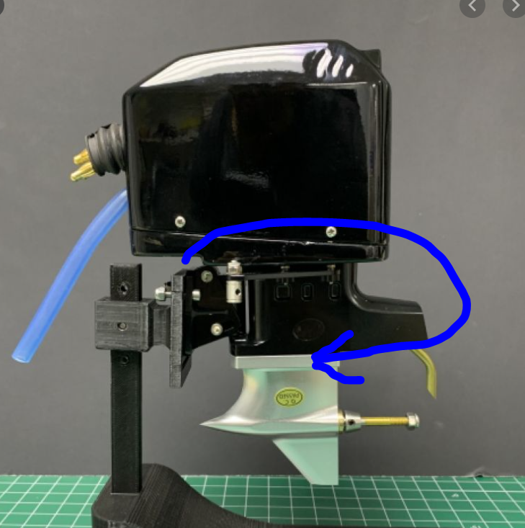

Attaching the servo here will make this rotate 360

## Attaching servo in the back of propellers

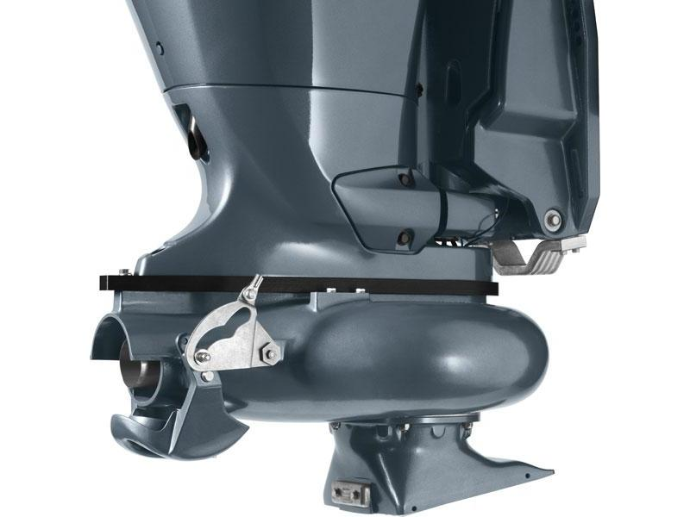

If the bow (bucket) covers the thrust flow, it will flow toward. There is a video describes the idea:

<https://www.youtube.com/watch?v=AfVV37OPb4A>

This mechanism is found in the “Jet Engine” and using Jet engine instead of TFL Outboard engine has some advantages:

- Servo based reversing mechanism could be in the chassis which helps it be water resistance.

- There is commercialized system that we can purchase:

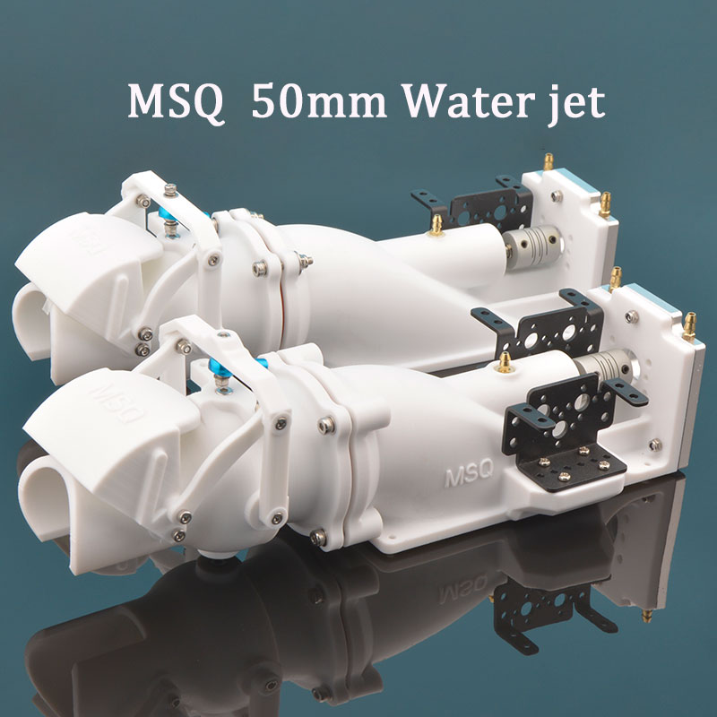

3D printing <https://vi.aliexpress.com/item/4000643150931.html>

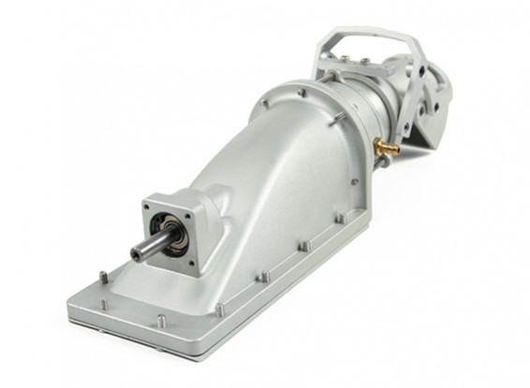

CNC version <https://hobbyking.com/en_us/40mm-jetpump.html>

In-action reverse mechanism:

<https://www.youtube.com/watch?app=desktop&v=Eucl2uOZhiQ>

## Reversible outboard

If we the reverse the outboard so saving a lot in cost and radio channels, also it could simplify the mechanical structure.

Conclusion:

In the purpose of choosing the engine of Joystick RC boat, there are 2 options are proposed:

|  |  |  |  |
| --- | --- | --- | --- |
|  | **Pros** | **Cons** | **Estimated cost** |
| **3D design the engine from bottom up** | . We can actively adapt the design with any kind of body (which will be discuss in the body part – we need a flat bottom instead of V-shape)  . We have experience with 3D design and manufacturing.  . Cheap, in term of rebuild and/or repair | . May take time: estimate of 2 weeks for design the engines, print, test and optimized  . Not much durable | $100 |
| **Buy the jet engine and design the reverse bucket** | . The jet engines are available in Vietnam, can be purchased quickly  . It is made from durable plastic | . Difficult to design to adapt with the given engine (servo mount, water resistance…) | $90 |
| **Buy entire engine with reverse bucket** | . It could work according to the test videos  . Do not need modify much | . Costly  . Take around 3 weeks to order from China | $100 |

# Remote control discussion

In the first phases, we will manually control the boat. For 2 individual motors, we need to use 2 sticks independently. In phase 3, we will need to create an interface to transform the control input from sticks to steering mechanism of Ardupilot. More about this must be describe in detail, but in short, Ardupilot has no way to control the dual jet engine (but it has something like the document “Joystick Piloting Project by Jørn Watvedt” referred to) so that we take the advantage of those given steering by mapping our RC controller inputs.

*For distinguishing, in this document, term stick or gimbal is used to describe the rod of the controller*

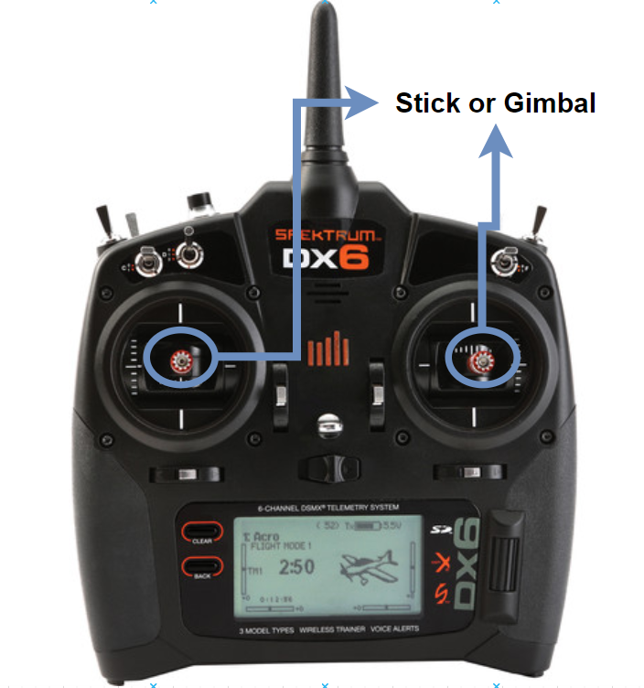

Typical RC Remote controller

Thrust created forward will be weaker than backward at the same input of power, this is because the backward thrust is generated by reflecting. Therefore, choosing a controller with Sticks having fine tune capability is very important. There are many cheap controllers out there coming with “toy style” drones, there joystick is very difficult to do fine tune (moving in short range). For example, the joystick modules are widely used in some DIY project will have the same characteristic with that cheap-drone-controller:

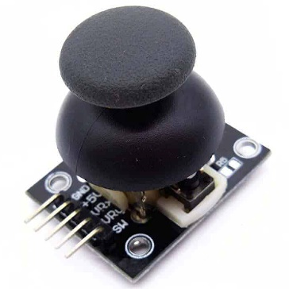

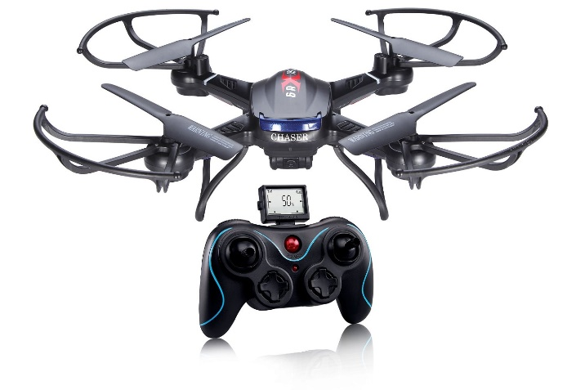

These controller’s joysticks are not suitable for first phases.

There are 2 ways to control the RC boat:

## Normal RC Remote control

The ordinary RC remote controls have 2 joysticks. Depending on typical vehicles and style of controlling, 2 joysticks can be used for multirotor, airplane, rovers… The right joystick is bounce for Up/Down and Left/Right direction which means when is move a position, by releasing, the joystick will be pulled back to the center by the spring (in side of the controller). The left joystick sometime just be bounce for Left/Right direction only, because the Up/Down is used for throttle control in multirotor or airplanes. To control 2 engines individually, we need to use both joystick simultaneously and we expect when releasing, both joystick could be bounce back to the center. There are some kind for RC remote controller can solve this problem, please examine these following videos:

This video show how a FRSKY Xlite could be modified from “Spring-ed” to “Unspring-ed”

<https://www.youtube.com/watch?v=Aa8y8FdvA9U>

Or this video, but for FRSKY QX7

<https://www.youtube.com/watch?v=ui0pmlBxlt8>

In the phase of implementing the autopilot, as mentioned above, the Ardupilot has nothing to do with vector thrust boat, so we need to “treat” it by creating a software adapter to get it work with our system.

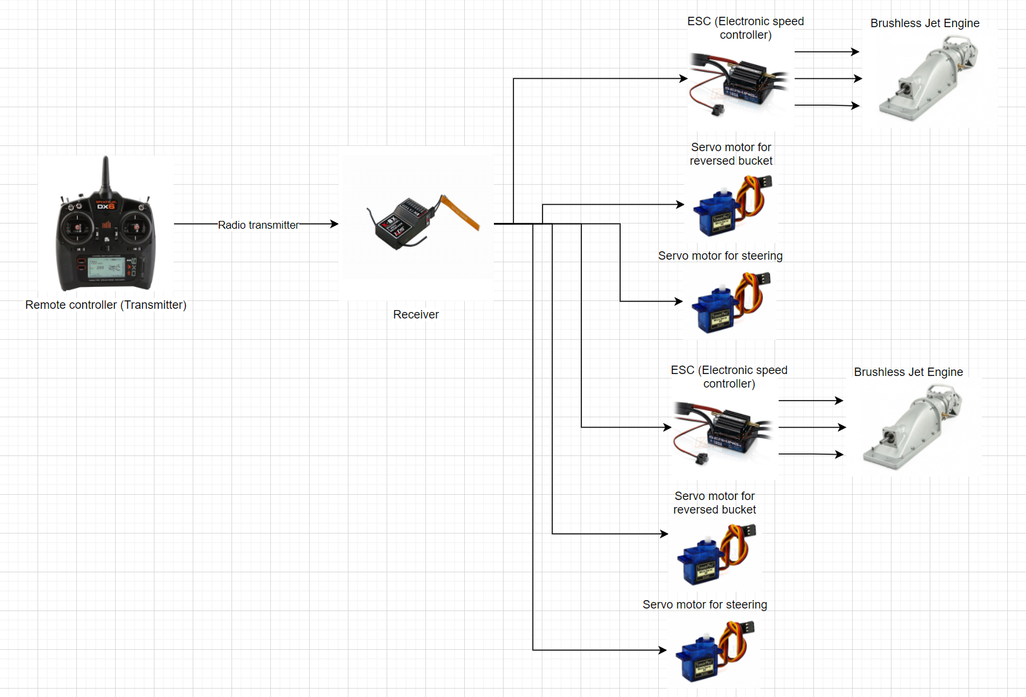

For phase 1 achievement, we will use some channels from the RC remote controller for manually manipulate the boat:

. 2 Channels for controlling speed of the engine

. 2 Channels for steering

. 2 Channels for reversing

In case the outboard engine is going to be used, we will have this diagram:

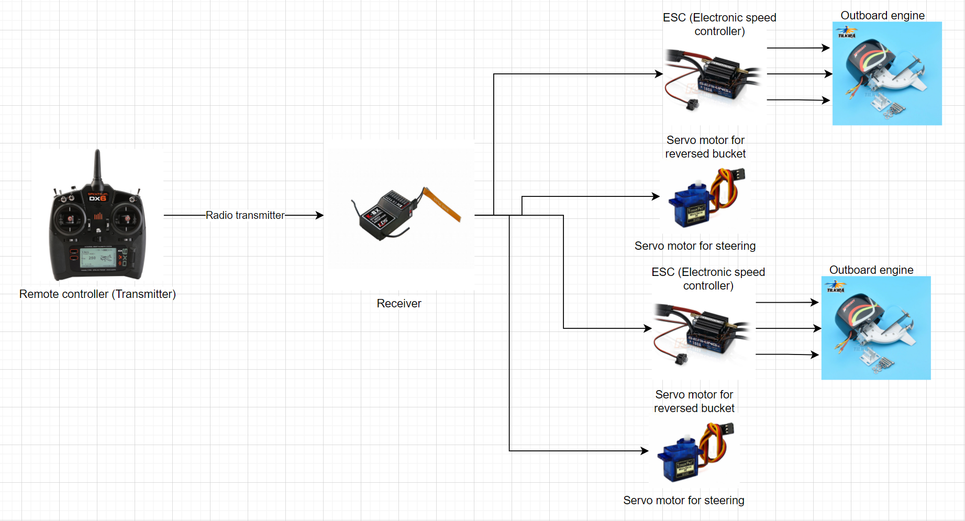

In this phase, we need to control the boat fully manual. In Ardupilot implementation, we will add the adapter:

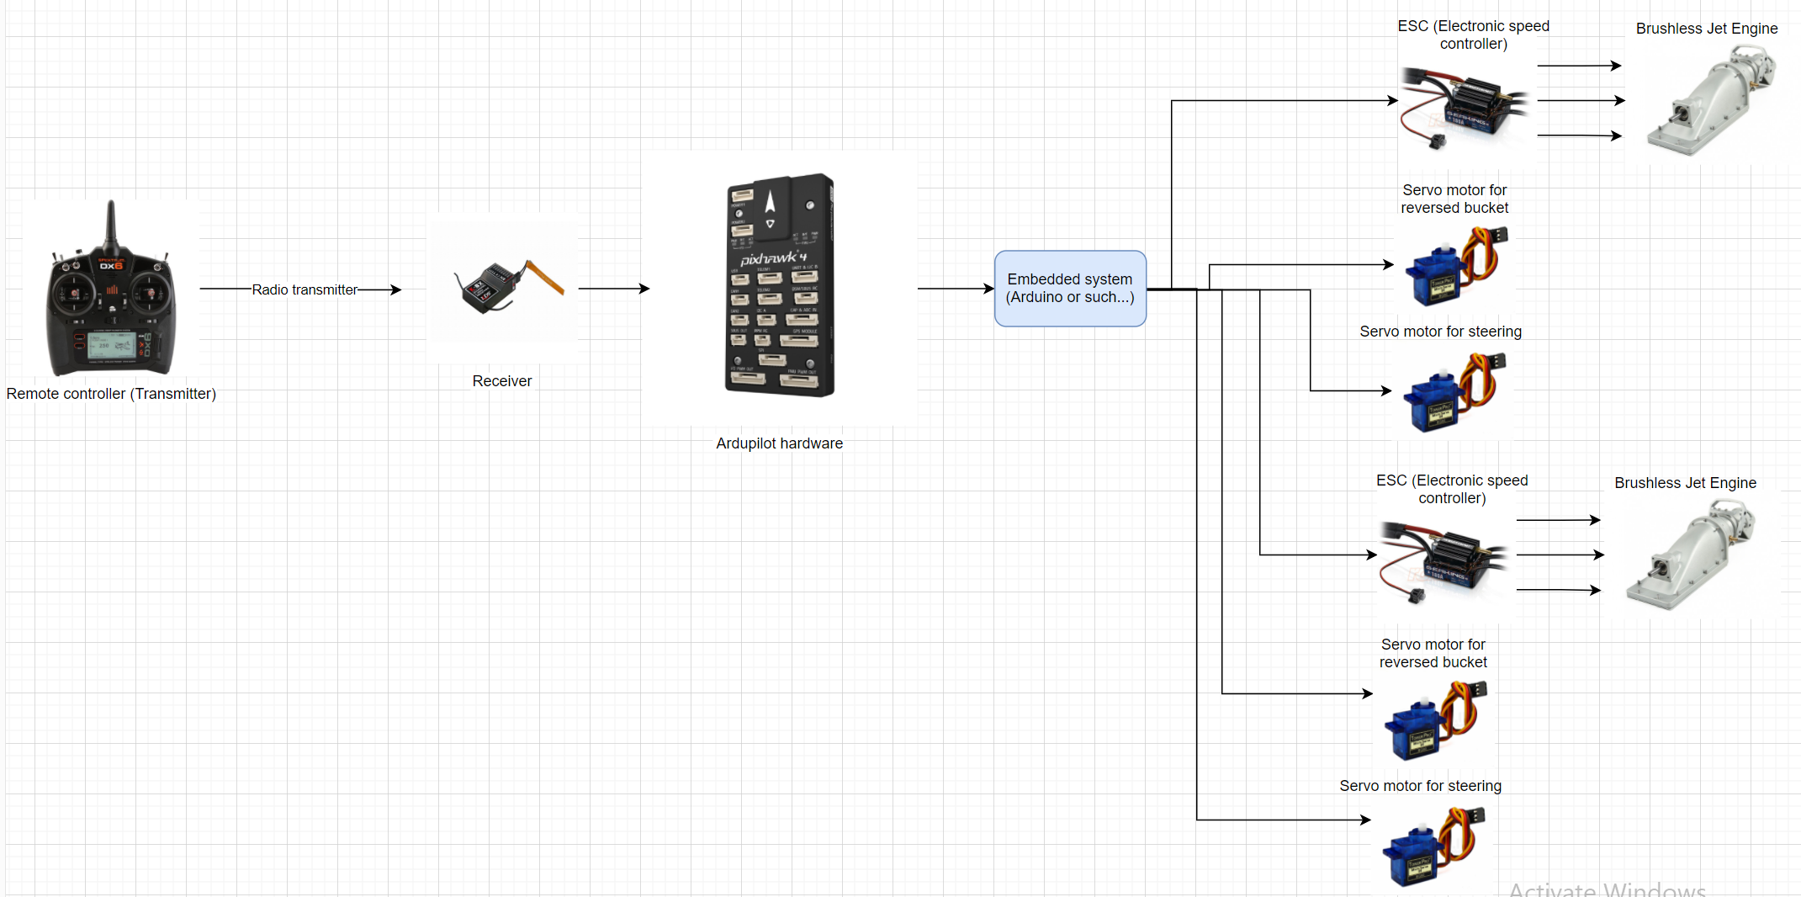

An embedded system or embedded PC can be used to receive the signals that output from Ardupilot (for example <https://ardupilot.org/rover/docs/rover-motor-and-servo-connections.html> there are some RC Output), turning them into 6 individuals signal for controlling servos and ESC.

*Note: This is sophisticated system will be novel so far because up to now, there is no sideway movement RC boat has been observed in the internet or real life yet.*

## Another way to control this RC boat

Whenever the Ardupilot adapting plan has been implemented successfully, we will substitute the Remote controller by a joystick.

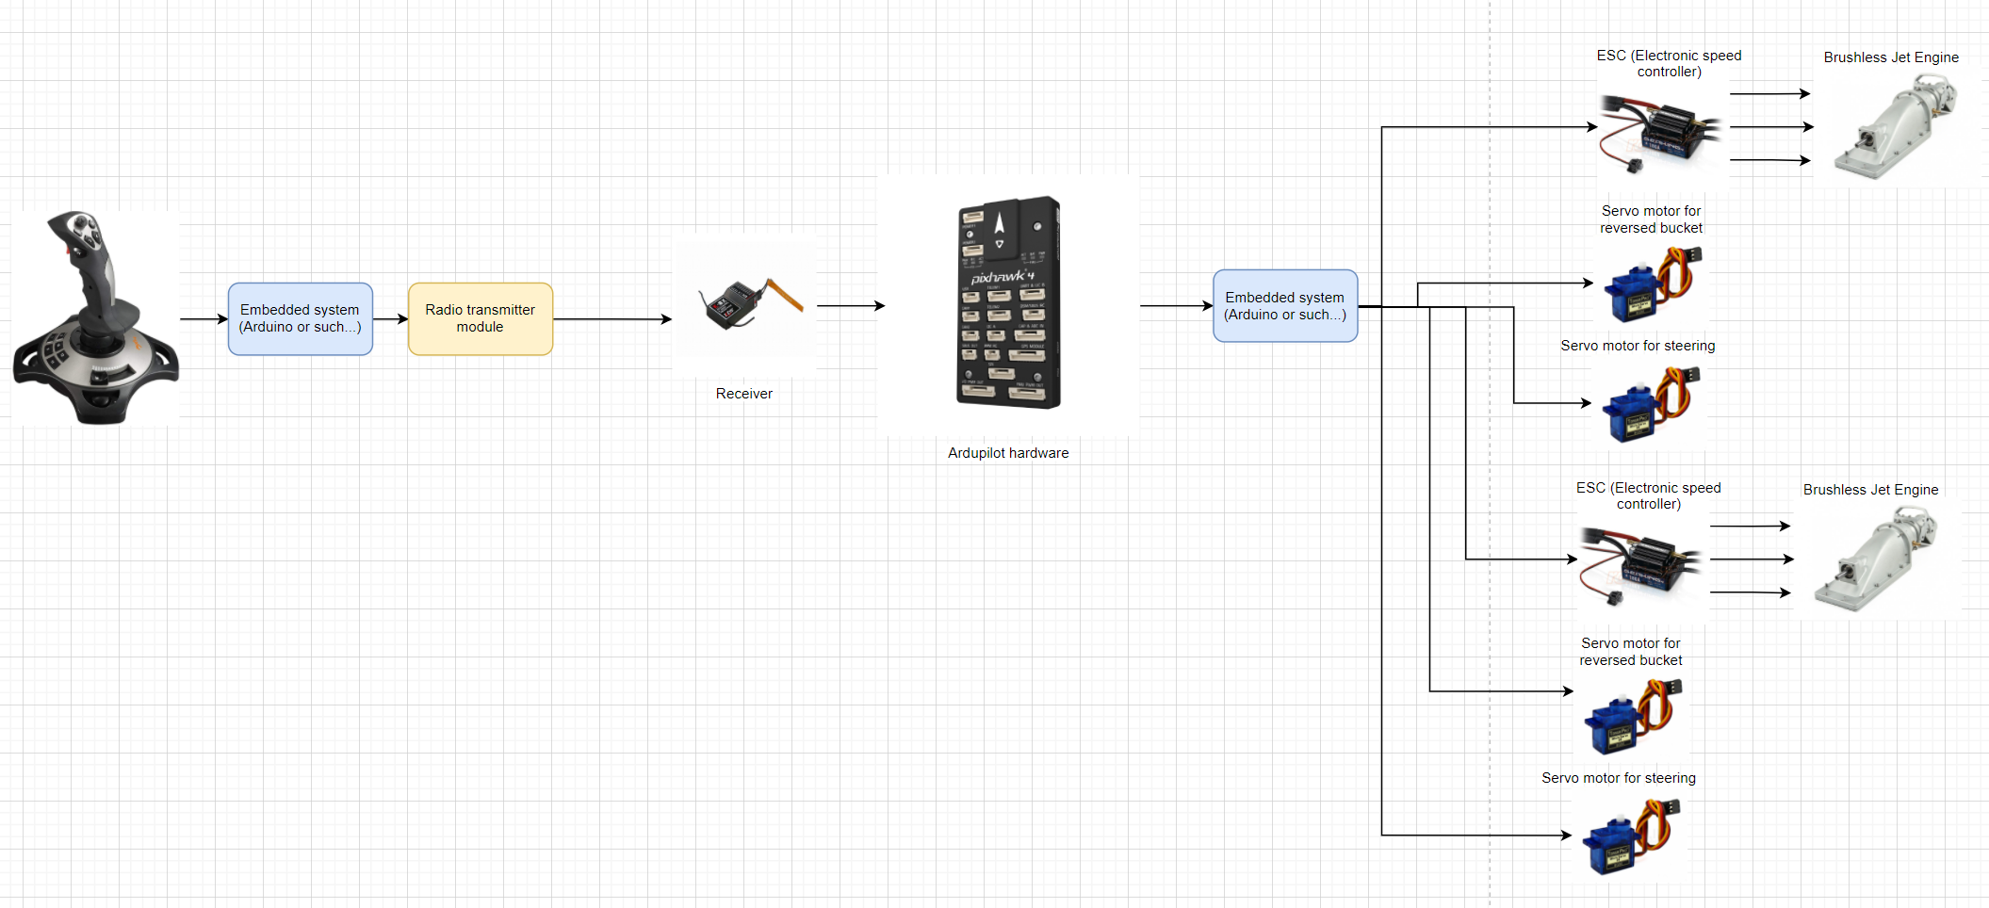

This makes the RC system more close to the realistic Joystick boat

Conclusion:

For phase 1, a use of RC Remote controller and receiver is needed. The range is no need to be too far, maximum of 500m is okay for testing. If we choose the popular RC Remote controller, we can increase the range by adding some external radio modules.

# Chassis discussion:

Pipe-style and flat-bottom are proposed

## Flat bottom

Flat bottom is needed because there 2 engines mounted in the back. Normal commercial composite boats usually have V-shape bottom. Estimating for 1 engine is 80mm wide, so at least 170mm wide is propose. Hull or boat made from plywood has enough space in the back for mounting.

A single plastic box may work but it is difficult to balance the weight and water resistance job. Moreover, because of the box shape, it is very hard to go straight in the water surface.

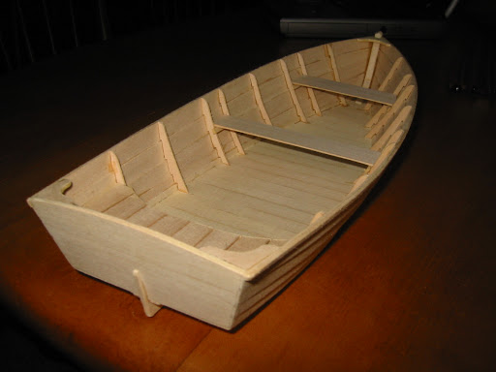

Single hull with flat bottom

## Another option is 2-body-boat

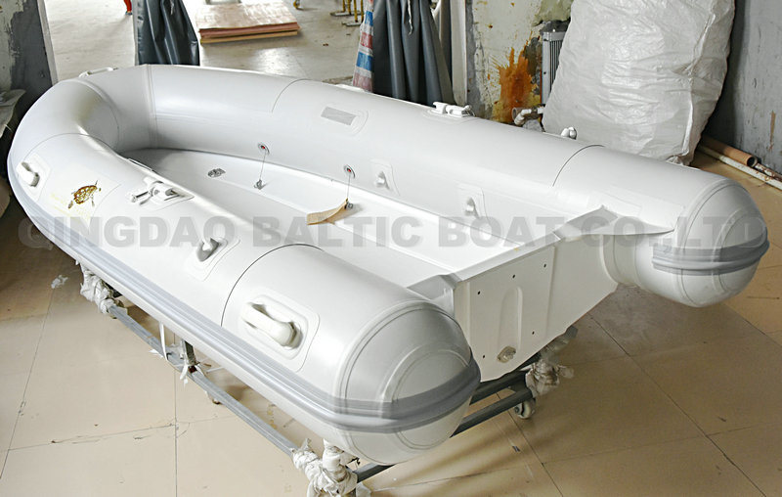

2 hulls are made from PVC pipe. At the end of the pipe is where 2 engines locate. This style has an advantage rather than the single hull which is distance from 2 engines can be modified by increasing or decreasing the space between 2 main pipes.

# Motor and ESC:

ESC can be purchased once, we can define the maximum power of ESC first and later on, if higher power motors if needed, we just replace the old one. 120A – 150A are sufficient to go. High range voltage input will help if we can use many kinds of battery. Battery in RC world is defined in S (series) which 1S is approximately 3.4V. Normally, ESC, motor and battery are must be synchronized. Motor and ESC maximum voltage of 6S are okay for work. Water resistance should be a point considered.

# Servo:

Steering and bucket servos can be sufficient enough for suffering the flow of water: 10kg – 16kg is okay. The gear must be metal because we do not expect any backlash in the movement. Water resistance is considered.

# Bill of materials

|  |  |  |  |  |  |
| --- | --- | --- | --- | --- | --- |
|  |  | Quantity | Estimated Cost | Total | Remarks |
| **Engine** | Self-designed engine | 2 | $100 | $200 | Estimate time for 3 weeks |
|  | Self-made bucket with given jet engine | 2 | $90 | $180 | Estimated time for 1 weeks  http://www.vietrc.com/Content/Images/uploaded/LinhKien/RapTau/TurboJet/tubor-jet-24mm-TLF-motor-size-29-36-4.png |
|  | Fully purchased | 2 | $100 | $200 | Including shipping fee and taxes, could be 15%. Waiting time can be 3 weeks or more  _DSC0074 |
|  | Outboard | 2 | $100 | $200 | <https://vi.aliexpress.com/item/32878931653.html> |
| **Chassis** | Dual hull | 1 | $60 | $60 | Made from PVC  3D model has not been designed yet |
|  | Single hull | 1 | $50 | $50 | http://www.vietrc.com/Content/Images/uploaded/Cano/DuThuyen565mm/du-thuyen-565mm-4.png |
| **Controller** | Transmitter FRSky Xlite | 1 | $155 | $155 | Kết quả hình ảnh cho frsky x lite  Small  Easy to modify the spring  We can get it second of half of the price |
|  | Transmitter FRSky QX7 | 1 | $130 | $130 | Kết quả hình ảnh cho tay qx7  Durable  Cheaper than QX7 and can be bought second hand in half of the price |
| **Receiver** | Receiver X8R | 1 | $34 | $34 | Kết quả hình ảnh cho recevier x8r  1Km range in airbone, expected 700m in water  It has SBUS channel which is compatable to Ardupilot in the future |
| **Motor** | Rocket 4082 – 1600kV | 2 | $50 | $100 | <https://www.ebay.co.uk/itm/Rocket-4082-1600KV-1900KV-Brushless-Motor-for-Traxxas-M41-Catamaran-RC-Boat-Car-/174512683397>  Image 01 - Rocket-4082-1600KV-1900KV-Brushless-Motor-for-Traxxas-M41-Catamaran-RC-Boat-Car  Max 110A, 30V |
|  | Motor 3674-2250KV | 2 | $39 | $78 | <https://www.amazon.com/GoolRC-4Poles-2250KV-Brushless-Motor/dp/B07BGZWFMP>  https://images-na.ssl-images-amazon.com/images/I/61pl-qNAI9L._AC_SL1000_.jpg  Max 80A, 21V |
| **ESC** | 120A ESC Flycolor | 2 | $40 | $80 | <https://www.amazon.com/Flycolor-Waterproof-120A-Brushless-RCRunning/dp/B07486MWW3>  Kết quả hình ảnh cho 120A ESC Flycolor |
|  | 90A ESC Flycolor | 2 | $30 | $60 | <https://www.ebay.co.uk/itm/Flycolor-90A-Brushless-ESC-for-RC-Boat-2-6S-with-5-5V-5A-BEC-V1D1-/124224893177>  Kết quả hình ảnh cho 90A ESC Flycolor |
|  | Reversible ESC | 2 | $60 | $120 | <https://www.ebay.com/itm/RW-RC-Brushless-ESC-30A-50A-70a-125a-200a-with-reversing-For-RC-car-RC-boat/174098089965?hash=item28890e07ed:g:n7wAAOSwW89d0CYr&var=472951988728>  Image 1 - RW-RC-Brushless-ESC-30A-50A-70a-125a-200a-with-reversing-For-RC-car-RC-boat |
|  | Reversible ESC | 2 | $65 | $130 | <https://vi.aliexpress.com/item/4000894083950.html?spm=a2g0o.productlist.0.0.72f1de07uw1rIs&algo_pvid=2f26114d-a82b-468b-aa6c-f0362c57516f&algo_expid=2f26114d-a82b-468b-aa6c-f0362c57516f-43&btsid=0bb0620316140682348664147ec53c&ws_ab_test=searchweb0_0,searchweb201602_,searchweb201603_> |
| **Servo** | JX Servo PDI-5513MG 13kg | 4 | $12 | $48 | <https://sea.banggood.com/JX-Servo-PDI-5513MG-13kg-Metal-Gear-High-Torque-Digital-Servo-For-RC-Models-p-1160022.html?cur_warehouse=CN>  Kết quả hình ảnh cho JX PDI-5513MG  No water proof |
|  | JX DC5821LV 20 Kg | 4  2 | $21 | $84  $42 | <https://www.ebay.com/itm/JX-Waterproof-Metal-Gear-JX-DC5821LV-20KG-Large-Torque-Digital-Coreless-Servo-/174125079363>  Image 1 - JX-Waterproof-Metal-Gear-JX-DC5821LV-20KG-Large-Torque-Digital-Coreless-Servo  Water proof |
| **Misc.** | Water cooling for motor | 2 | $20 | $40 | <https://www.amazon.com/Dilwe-Cooling-Water-Cooled-Control-Accessory/dp/B07MBDY377>  https://images-na.ssl-images-amazon.com/images/I/517lcGKAIyL._AC_SL1001_.jpg |
|  | Motor mount | 2 | $13 | $26 | <https://vi.aliexpress.com/item/32862155089.html>  Kết quả hình ảnh cho rc motor boat mount |
|  | Propeller | 2 | $15 | $30 | <https://www.amazon.com/Mxfans-Shaft-Center-Leaves-Propeller/dp/B07FKBR3BT/ref=sr_1_4?dchild=1&keywords=RC+Boat+Propellers&qid=1613207172&sr=8-4>  https://images-na.ssl-images-amazon.com/images/I/61Xi2RwRE2L._AC_SL1500_.jpg |
| **Accessories** | Glue, water cooling pipe, water pipe separator, servo link, screw… | 1 | $50 | $50 |  |

Prefer options are marked with highlight. Estimated cost is $824 for material only.

If we are using the outboard style, estimated cost is $666

*Note: Some of the parts can be purchased secondhand for saving.*

# Process timeline

|  |  |  |  |  |  |  |  |  |  |  |
| --- | --- | --- | --- | --- | --- | --- | --- | --- | --- | --- |
| **Weeks** | 1 | 2 | 3 | 4 | 5 | 6 | 7 | 8 | 9 | 10 |
| **Works** |  |  |  |  |  |  |  |  |  |  |
| Preparing engine |  |  |  |  |  |  |  |  |  |  |
| Preparing the chassis |  |  |  |  |  |  |  |  |  |  |
| Assembly |  |  |  |  |  |  |  |  |  |  |
| Testing |  |  |  |  |  |  |  |  |  |  |
| Fixing |  |  |  |  |  |  |  |  |  |  |
| Modification (if needed) |  |  |  |  |  |  |  |  |  |  |

*Note: Lead time or shipping time is not calculated yet; these could be concurrency.*

# Conclusion

Up to this point, there are almost enough material and preparation for constructing the work up to the end of phase 6.

Proposed work to complete the phase 6:

1. Completely sea-trial and test the manual RC boat

2. Adding Ardupilot hardware and sensors

2. Creating the software adapter

3. Automatically RC boat: working in the mode of Loiter, Auto, Guided… of Ardupilot.

# Preparation Up to Phase 6

Target until phase 6: RC boat can be controlled by the joystick

. Ardupilot powered system

\_ Autopilot

\_ GPS

\_ Compass

\_ Telemetry RF transceiver

. Software adapter to convert normal input into appropriate steering

\_ A joystick

\_ Embedded circuit

The most concern of this system is about navigation (compass and GNSS). This novel vector thrust steering method could not be simulated easily and no previous similar projects have been found in the internet for our reference so investing a little more in navigation is worth it. Because of this reason, using using most updated controller from Ardupilot is proposed which means, the system must be capable of:

. Running EKF3 – multi inputs state estimating called Extended Kalman Filter

. Dual GNSS system used for heading (combined with compass). This configuration costs a lot, so it is proposed not to use at the moment, instead just 1 GPS module and 1 compass is good to go. After the automatic system is stable enough and more precision is required, this dual GNSS system is going to be considered.

|  |  |  |  |  |  |
| --- | --- | --- | --- | --- | --- |
| **Autopilot** | Kakute F7 AIO | 1 | $50 | $50 | <https://shop.holybro.com/kakute-f7-aio-v15_p1173.html> |
| **GNSS receiver (AKS GPS module)** | F9P | 2 | $220 | $440 | <https://www.sparkfun.com/products/16481> |
|  | M8N and Compass | 1 | $42 | $42 | <https://shop.holybro.com/pix32-gps-module_p1099.html> |
| **Telemetry system** | 500mW version | 2 | $45 | $45 | <https://shop.holybro.com/transceiver-telemetry-radio-v3_p1103.html> |
| **Arduino** | Arduino Nano | 1 | $4 | $4 |  |
| **Joystick** | 3-axis joystick  JH-D300X | 1 | $60 | $60 | <https://vi.aliexpress.com/i/1487233086.html> |
| **Teensy** | Teensy | 1 | $40 | $40 | Including shipping |
| **Accessories** | Test board,  electric wire, solder lead, enclosure misc… | 1 | $70 | $70 |  |

It is $305 in total, not including shipping and tax

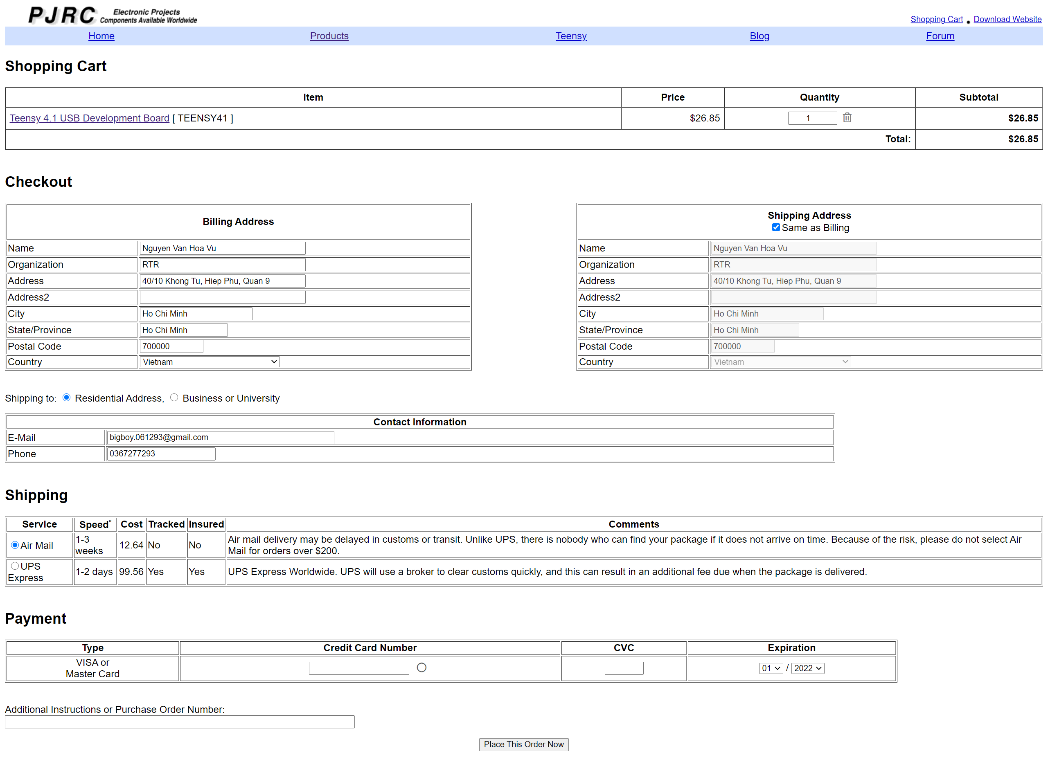

Teensy shipping is

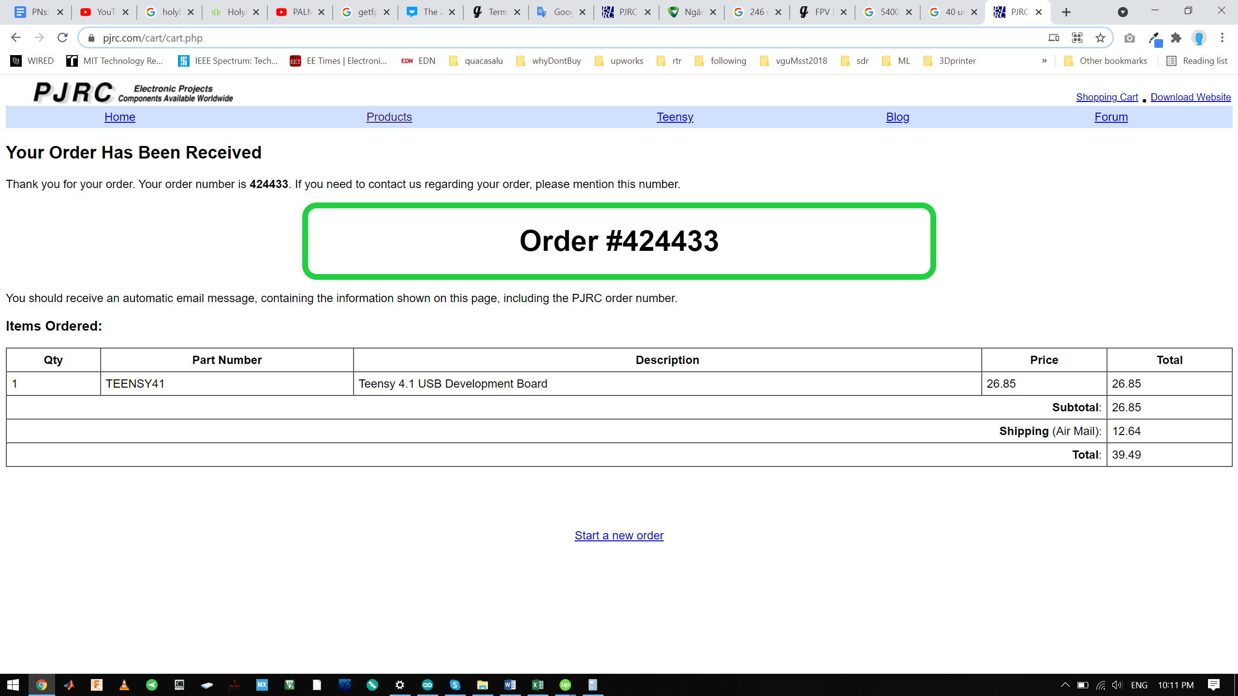

**424433**